INFT2150 – BUSINESS ANALYSIS

BUSINESS REPORT GROUP ACTIVITY – ASSESSMENT 1

0

|

Page



**INFT2150_CAL-THU_PM2**

**Asim Faiaz – C3296515**

**Ethan Hickling – C3349789**

**Greg Fletcher – C3021371**

**Patrick Moller – C3330487**

MenuLog Business Report

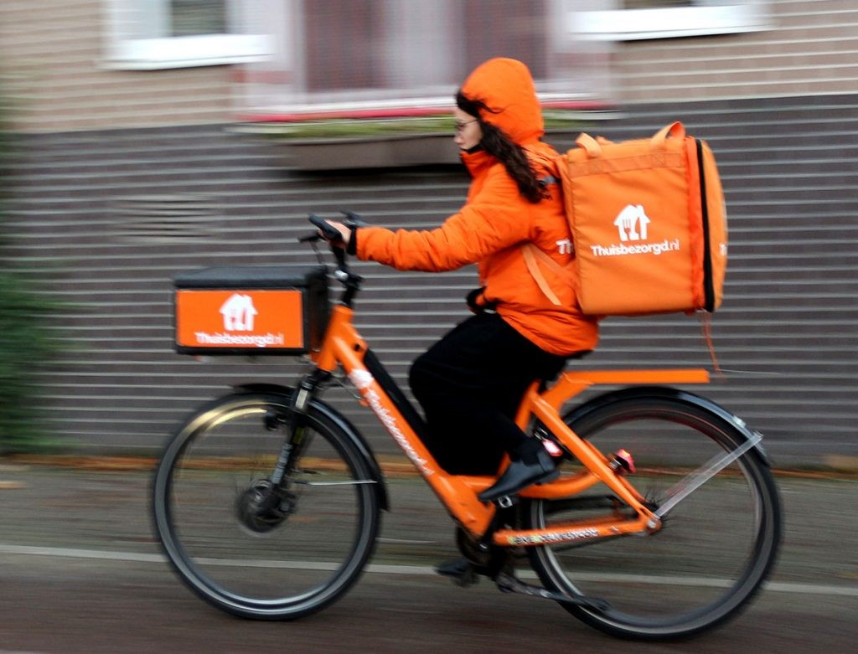

Contents

Executive Summary 2

1.0 Objectives 3

2.0 Systems Modelling 4

2.1 Rich picture 4

2.2 Use case diagram 4

2.2 Context-level diagram 6

2.3 Level-1 Data Flow Diagram 7

3.0 Stakeholder Analysis 8

4.0 Industry analysis 10

4.1 SWOT Analysis 10

4.2 VRIO Analysis 11

4.3 RIC Analysis 11

4.4 Prioritized SWOT Analysis 12

4.4 Porters Five Forces Analysis 13

5.0 Problem identification 15

6.0 Next steps 17

7.0 List of references 19

Appendix 1 – Problem Definitions 21

Appendix 2 – Rich Picture Diagram 26

Appendix 3 – Use Case Diagram 27

Appendix 4 – Context Level Diagram 28

Appendix 5 – Level 1 Data Flow Diagram 29

Appendix 5 – Prioritized SWOT Analysis Diagram 30

Group Activity Overview 31

# Executive Summary

Menulog was created in 2006 in Sydney Australia. It launched its first IOS app in 2009 and its first Android app in 2011. Designed to be a pioneering online food delivery service it began with little to no competition (1. Menulog). However, its initial success was a catalyst in the creation of many other online food ordering apps and businesses. Competition grey very quickly, with companies such as OrderUp! DeliveryHero, EatNow, and of course Uber Eats are all beginning to enter the Australian scene (2. Smart Company, Domonic Powell)

This report will openly feature the objectives the report desires to achieve, followed by systems modelling. The system modelling will open with a rich picture: a simple modelling diagram of the process of the business. This is then followed by a Use Case Diagram: the use case diagram shows the users and how they interact throughout the system, and how the system then interacts with them.

The final diagram is the context-level data flow diagram, which contains the one main process and the features of the entire rest of the system, including the relationship between internal and external entities.

Continuing from the diagrams, a stakeholder analysis is a vital section of a business report. The stakeholder analysis for Menulog will outline the stakeholders of the business and how they interact throughout Menulog's operations. The stakeholders will be defined and placed in their correct positions throughout the business. Related to the stakeholder's analysis is the SWOT analysis. A SWOT analysis stands for, Strengths, Weaknesses, Opportunities, and Threats. These 4 ideas are incredibly important for a business to take into consideration, with none being more important than the other.

Once the analysis of the stakeholders is complete and the SWOT analysis has finished the identification of the problems becomes necessary. With the entire system defined, described, and analysed, targeting the problems within the system proves vital in growing the business and maximising its efficiency.

Finally, Menulog will need to brainstorm the steps they need to take to achieve their goals, increase efficiency, and make sure no threats, such as competition, inhibit Menulogs ability to grow as a company.

# 1.0 Objectives

This report will analyze Menulog from top to bottom. Menulog is an Australian and New Zealand online food and beverage ordering app. It currently has over 30000 restaurant partners across the 2 countries. It was founded in 2006, and since then Menulog has experienced many challenges, including competition, resources, working conditions, and very recently Covid restrictions. Considering this, this business report will deconstruct the business, analyze it completely with SWOT analysis, system modelling, stakeholder analysis, problem identification, and other vital business analysis techniques.

References to articles, other case studies, and related businesses will be used to create a relatable source of analysis for Menulog and their competition and goals. Finally, after the report has completed its goal in an in-depth analysis, steps to increase, upgrade and solidify Menulog as an efficient and effective food and beverage online ordering app will be described. The steps will be stated, the outcome will be explained and the process to achieve the end goal for each step

# 2.0 Systems Modelling

## 2.1 Rich picture

Rich pictures are used to essentially create a mental model of a system, and allow the processes, operations and actors to unfold in a way that anyone can view and have an understanding of the system. Rich pictures have no set techniques or rules in the way they are created. This rich picture was created to give an overall view of the system without going too in depth, as the following Use-case diagram and context-level diagram will show a more detailed diagram of the system.

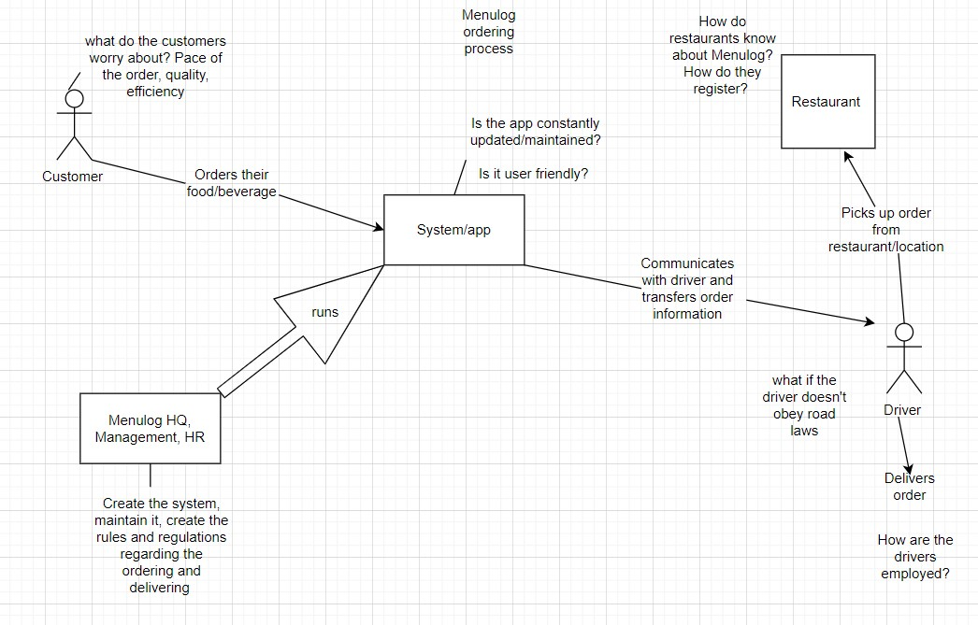

## 2.2 Use case diagram

The use case diagram is used to show how external entities and use cases interact with the system while keeping the functions of the system on track. Here’s a brief explanation of the use case diagram.

**Drivers:**

▫ Log In to the app and the app will match the nearest pickup to the driver

▫ Driver needs to accept the order in order to do any further action

▫ Driver needs to keep updated on the app about the delivery status from Start driving to the restaurant to Park at customer’s location

▫ Driver can seek help if needed **Customer:**

▫ App will show the customer the nearest restaurants available to order foods ▫ Customer will choose their meals

▫ Customer will pay for that

▫ After the expected time customer will receive the order

▫ Customer can seek for help if needed **Restaurant:**

▫ Restaurant will accept customer order and update on app how long to make the fresh meal

▫ Restaurant staff ask for the order number from driver in order to give the food bag

▫ Restaurant update status when driver leaves the restaurant **Customer Service:**

▫ Customer service will respond to any help from the Driver or customer.

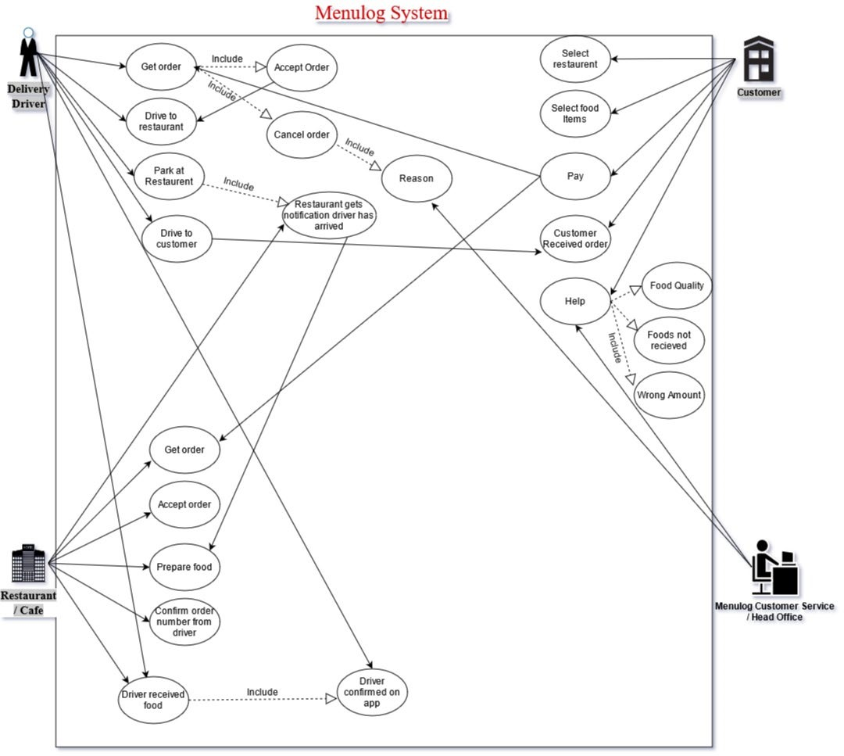

## 2.2 Context-level diagram

The Menulog context level diagram is focused on the Menulog Food Delivery System. At the context level, the food delivery system is a single process with three entity’s Customers, Restaurants, Delivery Drivers. The context level diagram demonstrates how the data flows from the Customer when they place an order through the Delivery system and onto the restaurant as a Food Order. The restaurant confirms this order and advises of a pick-up time, which is processed through the delivery system and a delivery request is sent to the delivery drivers. Once a delivery driver accepts the delivery, a confirmation is sent back through the system and onto the customer, with the approximate delivery time and the driver's details.

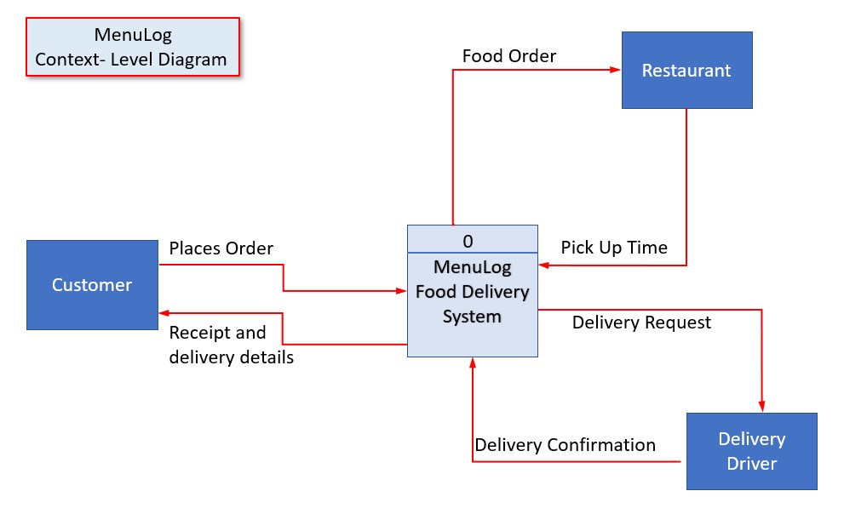

*Figure – 3 – MenuLog Context – Level Diagram*

## 2.3 Level-1 Data Flow Diagram

Menulog’s level 1 data flow diagram has broken down the single Menulog Food Delivery

System process of the context level diagram into three sub-processes, Food Order System, Payment System, and Delivery System. The level 1 diagram has also introduced the admin databases of the MenuLog Platform and clearly identifies the two-way data flow between these databases and the systems. The diagram demonstrates what appears like a straightforward process of a consumer ordering food online and a driver delivering it to their door, is a much more complex transaction with multiple systems, databases, and actors all working independently and but also as part of a larger machine to untimely have a delivery driver pick up the consumers food from a restaurant and deliver it to them.

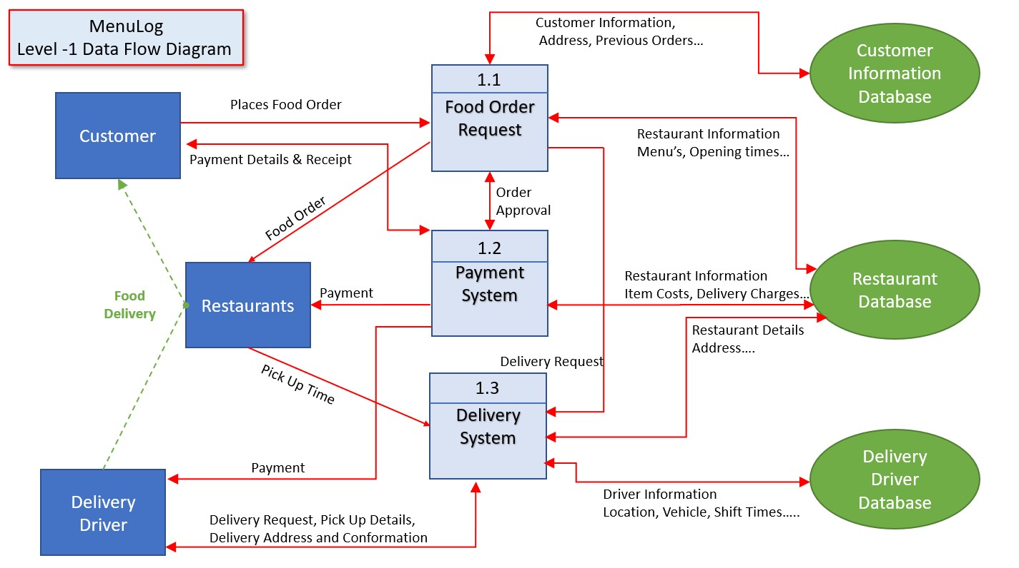

*Figure – 4 – Menulog Level -1 Data Flow Diagram*

# 3.0 Stakeholder Analysis

The stakeholder analysis identifies the key person or groups that have an interest in Menulog. Stakeholders are both internal and external to the business. Once the stakeholders have been identified, their attitudes and influence regarding MenuLogs current operations will be ranked and then a strategy formulated to gain their support or reduce their impact

|  |  |  |  |  |
| --- | --- | --- | --- | --- |
| **Stakeholder** | **Attitude** | **Influence** | **Involvemen**  **t** | **Strategies for obtaining support or reducing obstacles.** |
| **MenuLog Owners** | Low | High | Responsible | Corporate owners of MenuLog – Eat  Now would have little time for MenuLog’s everyday operations but have a massive influence over the business direction. The owners need to be informed of the process throughout the journey and responsible for the sign-off of new business strategy's |
| **Menulog Senior Management** | Medium | High | Accountable | Senior management needs to be informed all the way through the process. Senior management will be involved from the beginning of the business analysis process and will be accountable for the process and system changes that will be implemented. |
| **Menulog Employee** | Low | Low | Involved | Employees need to be informed, consulted, and involved through the process. Employees need to feel empowered that their ideas will be heard and they play a critical role in the business. |
| **Restaurant Owners** | High | Low | Consulted | Restaurant owners have a massive investment in the success of the platform, this is even more prevalent during Covid restrictions. Restaurant owners need to be consulted and informed |
| **Menulog**  **Delivery Drivers** | Low | High | Involved | Delivery drivers might have little interest, except for personal delivery totals, but their influence over MenuLog’s operations especially its reputation is high. Consumers won't order on the platform again if their |
|  |  |  |  | food arrives cold or does not arrive at all. MenuLog’s proposal to make drives employees rather than contractors is going to involve the drives in the process and raise their attitude towards Menulog. |
| **Competitors** | High | low | Informed | MenuLog’s competitors like UberEATS and Deliveroo have high interest in what MenuLog is doing in a bid to get a competitive advantage. MenuLog needs to undertake a consumer focus strategy instead of a competitorfocused strategy. By focusing on a consumer, they will enhance the consumer experience which will increase traffic on their platform. |
| **Regulators / Government** | Low | High | Informed | Changes in consumer, employment laws, and government regulations could have a significant impact on MenuLog’s operations. MenuLog needs to invest internal resources to identify potential changes in laws/regulations and then formulate a response change plan to either lobby the government or minimise the impact. |
| **Restaurant Employes** | Low | Low | Informed | Restaurant employees have little interest in influence over Menulogs operation, they are informed throughout the process. |
| **Menulog**  **Business Partners** | Medium | High | Consulted | Partnering with global brands like McDonald’s and Burger King has considerable influence over MenuLog due to their global scale. To lose a partnership would have drastic effects on the company's turnover. Menulog’s strategic partners need to be involved and informed throughout the process. |

*Table 1 – Stakeholder Analysis*

# 4.0 Industry analysis

## 4.1 SWOT Analysis

A critical SWOT analysis has been conducted to evaluate MenuLog’s Strengths and Weaknesses in its internal resources and capabilities along with its Opportunities and Threats in its external environment.

|  |  |  |
| --- | --- | --- |
|  | | **MenuLog SWOT Analysis** |
| **Strengths** | ♦  ♦  ♦  ♦ | Consumers have over 30,000 restaurants to choose from on the MenuLog platform  MenuLog gives restaurants the option to use their own delivery drivers or use MenuLog drivers  Restaurants do not pay a fee to sign up to the platform  Consumers can order pick-up meals from restaurants as well as delivered |
|  | ♦ | Menulog services coverage is 92% of the Australian population |
|  | ♦ | MenuLog’s merger with Eat Now |
|  | ♦ | Strategic partnership with McDonald's, Burger King... |
| **Weaknesses** | ♦  ♦ | More Restaurants are choosing to use their own delivery drivers  MenuLogs cost structure will increase when delivery drivers become employee’s instead of contractors. |
|  | ♦ | Consumers frustration with the inability to cancel orders through the app. |
|  | ♦ | Due to delivery drives being contractors, quality control is poor, and this had reputation consequences on both MenuLog and the restaurants when food is delivered cold, late, or not at all. |
| **Opportunities** | ♦  ♦  ♦ | Global expansion – Menulog is only in Australia and New Zealand  Covid-19 lockdowns and restrictions – these have seen a boom in online food deliveries.  Integration of other services into the Menulog Order pads within the restaurant. At the moment they are a one-use piece of IT equipment, adding more functions like stock ordering utilising data from food orders. |
|  | ♦ | Consumer Data – Menulog acquires significant levels of consumer behaviours data. By utilising data analytics MenuLog will be able to tailor direct marketing campaigns to consumers just before the time they normally order food. |
| **Threats** | ♦  ♦ | Many competitors in the food delivery industry. The Australian market has UberEATS, Deliveroo, Door Dash and they are huge international brands not in Australia yet, Grub Hub, Food Panda... The price sensitivity of the consumers, if MenuLog charges too much for delivery, consumers will either pick up the food or dine in. |
|  | ♦ | Social awareness of the charges Menulog charges restaurants and consumers choosing to go direct to the restaurant |
|  | ♦ | Digital innovation of the platforms – UberEATS benefits from Uber’s global size and have the scale for substantial investment in digital innovation. |

*Table 2 – SWOT Analysis*

## 4.2 VRIO Analysis

Investigation into MenuLog’s strengths has identified four standouts that are critical to Menulog’s long-term success and profitability. The four strengths have been analysised using the VRIO techniques that will rank the individual characteristics of the strengths against each other. VIRO identifies how Valuable, Rare, Inimitable, and Organised the strengths are given Menulog a prioritised list they will be able to utilise when formulating a strategy of competitive advantage.

|  |  |  |  |  |  |
| --- | --- | --- | --- | --- | --- |
| **MenuLog VRIO Analysis** | | | |  |  |
| **Strengths** | Valuable (V) | Rare (R) | Inimitable (I) | Organised(O) | **Priority** |
| **More than 4 Million active customers** | ✓ | ✓ | ✓ | ✓ | **1** |
| **Partnerships with “Favourite Brands”** | ✓ |  |  |  | **3** |
| **Over 30,000 restaurants on the platform** | ✓ |  | ✓ |  | **2** |
| **Option for Restaurants to supply their own delivery drivers and save money** |  |  | ✓ | ✓ | **4** |

*Table-3 VRIO Analysis*

## 4.3 RIC Analysis

The SWOT analysis identified four key weaknesses in Menulog’s operations and if left unchecked they will have drastic effects on MenuLog's long-term probability. Utilizing a RIC analysis, the weaknesses can be prioritised. The RIC analysis ranks the weaknesses in a prioritised list relating to the business's ability to turn them into strengths.

|  |  |  |  |  |
| --- | --- | --- | --- | --- |
| **MenuLog RIC Analysis** | |  |  |  |
| **Weaknesses** | Rare (R) | Inconvertible (I) | Costs © | **Priority** |
| **Cost Structure will increase with the introduction of the**  **MenuLog EBA and classifying their delivery drivers as employee’s instead of contractors** | ✓ | ✓ |  | **1** |
| **Restaurants have no quality control over MenuLog drivers** |  | ✓ | ✓ | **3** |
| **Consumers frustration with the inability to cancel orders through the app** |  | ✓ | ✓ | **2** |
| **More Restaurants using their own delivery drivers – lower commissions for MenuLog** |  |  | ✓ | **4** |

*Table 4 – RIC Analysis*

## 4.4 Prioritized SWOT Analysis

Combining the SWOT, VRIO, and RIC analysis’s a prioritized SWOT analysis has been created. The provides MenuLog with an overview of the focus points required in their business strategy. By leveraging from their top strengths to increase market growth, the increased revenue will be able to be invested into strategies to turn their weaknesses into strengths.

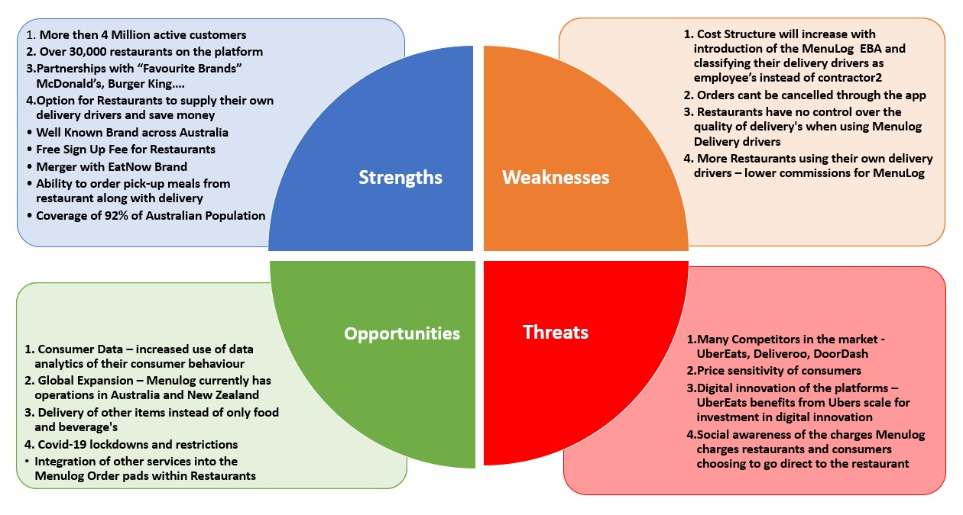

*Figure – 4– MenuLog Prioritized Analysis*

## 4.4 Porters Five Forces Analysis

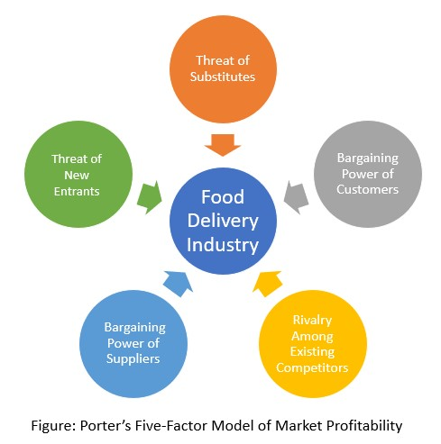

Building on the foundation of the SWOT analysis, and industry analysis utilsing Porter's Five forces of Market Profitability has been conducted on MenuLog’s current operations. Porter's Five Forces analysis identifies the competing forces that define a company's position in the market and what strategies MenuLog needs to undertake to be profitable.

|  |  |  |  |  |
| --- | --- | --- | --- | --- |
| **Porters Five Factors** |  | **Level** |  | **Strategy** |
| **Threat of substitutes** | ♦ | High – If Delivery Costs are too high consumers will pick up or dine in (after Covid). | ♦ | Menulog needs to maintain the attentiveness of food delivery, during the Covid restrictions the food delivery industry has boomed and for MenuLog to remain profitable then, needs to build a stable business model that will ride out the sudden fall in trade when Covid restrictions are removed. |
| **Bargaining power of customers** | ♦ | High – Low switching costs for consumers to change online food delivery platforms | ♦ | The online platform needs to be as intuitive and easier to use as possible. The customer experience expectations need to be met, otherwise they will switch to another platform. |
| **Rivalry**  **Among**  **Existing**  **Competitors** | ♦ | Extremely High - Rivalry between the established is extremely competitive. | ♦ | MenuLog needs to continuedly to invest in fresh marketing campaigns (I.e., Snoop Dog adverts) to differentiate itself from its competitors. |
| **Bargaining**  **Power of**  **Suppliers** | ♦ | Low - Restaurants have little power over MenuLog  Operations | ♦ | MenuLog needs to entice more restaurants onto their platform, the more restaurants there is the choice the customer has which will increase the customer experience. Currently, Menulog has one of the lowest commissions compared with its biggest rivals, by keeping this commission as low as possible they will be able to increase their market share. |
| **Threat of**  **New**  **Entrants** | ♦ | Medium-High barrier to entry due to the excessive costs to set up and market a national wide delivery platform. High chance of another global online food delivery business would set up in Australia | ♦ | To combat the threat of new entrants, especially large international brands like Grub Hub, Delivery Hero, MenuLog needs to capture a significant market share of the Australian and New Zealand food delivery market. New entrants will not enter the market when there is little chance of them gaining market share. |

*Table 5 – Porters Five Forces*

# 5.0 Problem identification

There are several problems that every company face’s, especially ones that have seen rapid growth. Most of these problems include uncertainty, financial management, regulation, recruitment, technological support, exploding data, customer service and issues around reputation. Even though each of these needs to be considered for Menulog now and in the future, those that need most attention relate to Competition, Privacy Concerns, Technological Concern and Service management, Appropriate Driver’s.

Competition:

Competition is one is the major problem Menulog is facing right now. According to a survey Uber eats is the biggest competitors of Menulog. Uber eats connected with a huge range of restaurants across Australia. Uber network is available Newcastle zone to Armidale or Coffs

Harbour Zone where menulog doesn’t have any connection with most of the Lake Macquarie’s restaurants. This is the risk Menulog is facing which reducing Menulog’s market. Also, Menulog has a minimum order option which is less popular to the users. So, when Menulog is thinking to take a step further and entitle their independent contractors as employee they also need to do something about that, so they don’t lose the market. This is a disadvantage of Menulog at this moment.

Privacy Concern:

Privacy is another issue menulog needs to consider. As menulog is storing a huge amount of data such as Customer Address, Phone number and other private details. Most importantly menulog stores customer credit card details. Not only the customer but also the driver’s personal information such as DL details, Bank information, etc.

Technological Concern:

According to a research Menulog app not so user friendly and less favourable to the customers. Lack of user feedback makes the app more difficult to use. For their employees the driver app also needs to be perfect, so they don’t miss a point. Menulog app run on an algorithm which matches the order according to the driver’s distance and the same algorithm the app use to count the cost of the delivery such as driver’s payment. If the algorithm doesn’t hit right the restaurant or the driver may not get the order. When Menulog is thinking to make their drivers as employee they need to look for the accuracy of the app. They need to pay the driver a minimum wage even if there’s any order or not.

Menulog needs to consider that issue.

Service Management:

Menulog customer service is facing some problems at this stage according to a survey website. Menulog needs to look into this issue so to take control over their drivers so the driver can get proper support. Another important issue is restaurant support and Menulog needs to look into that just to make sure the customer’s waiting period is not too long.

Drivers and Restaurants are two main assets of Menulog’s business.

Appropriate drivers:

At this stage Menulog is appointing as driver to anyone who is applying. When they are thing to make the drivers employee, they need to take a step further to avoid some unwanted situations. For example, if a driver meets a car accident and doesn’t have an insurance, who will pay for? If a driver gets a fine such a speeding or road cameras or toll, who will pay for that? This is another challenge for Menulog.

# 6.0 Next steps

Competition Problem:

As we mentioned earlier that competition is one of the major problems Menulog is facing. There are a couple of actions Menulog should take to eliminate those problems. According to the full analysis there are several big companies such as Uber Eats, Door Dash, Eat Now are creating a challenge for Menulog. So, Menulog should do a complete a competitor analysis on those companies about their business policies, their disadvantages, lacks and everything. Menulog should process data and identify potential gaps in the food delivery industry.

Privacy Concern:

There is no doubt that Menulog needs to collect a huge amount of personal data on daily basis and it’s part of the business. Menulog’s quick growth has led to privacy issues. The first thing Menulog needs to think about to resolve that issue is what Privacy policy are best to keep user’s personal information secure and safe. Menulog should take advantage of the features or offers that customer are enjoying but they need to identify first.

Technological Concern:

Technology is the key to Menulog’s business. As we discussed earlier about a couple of things on the menulog app, both User and Drivers. Both apps run on algorithms. According to the research the customer app is less user friendly and has minimal touch with the customer. Menulog needs to look into that problem and require some top-class Programmer to support the app so there will be no downtime.

Appropriate Drivers and Support:

Before starting the new research on the drivers to make them employee, Menulog should launch some Induction session with the new drivers. Driver’s Driving history check should be compulsory to work with Menulog. Introduce the drivers about the Menulog road rules policy such as not using the toll roads, Avoid heavy traffic areas etc.

# 7.0 List of references

Goodman Fielder Food Service. (2021, March 19). *The Future of Food Delivery Services in Australia for the Changing Hospitality Landscape*. <https://www.gffoodservice.com.au/idea/future-of-food-delivery-australia/>

Menulog. (n.d.). *About Us*. Retrieved September 7, 2021, from <https://www.menulog.com.au/info/about-us>

Partridge, S., Gibson, A. A., Redfern, J., Roy, R., Raeside, R., & Jia, S. (2021, August 13). *Appetite for convenience: how the surge in online food delivery could be harming our health*. The Conversation. [https://theconversation.com/appetite-for-convenience-howthe-surge-in-online-food-delivery-could-be-harming-our-health-163348](https://theconversation.com/appetite-for-convenience-how-the-surge-in-online-food-delivery-could-be-harming-our-health-163348)

*Popular delivery platforms and how to take advantage of them*. (2021, August 2). Unilever Food Solutions. [https://www.unileverfoodsolutions.com.au/chef-inspiration/fightingcovid-19-together/food-delivery-101/popular-delivery-platforms-and-how-to-takeadvantage-of-them.html](https://www.unileverfoodsolutions.com.au/chef-inspiration/fighting-covid-19-together/food-delivery-101/popular-delivery-platforms-and-how-to-take-advantage-of-them.html)

*The pros and cons of online delivery services*. (n.d.). TipTop Foodservice. Retrieved September 7, 2021, from [https://www.tiptop-foodservice.com.au/all-ideas/the-prosand-cons-of-online-delivery-services](https://www.tiptop-foodservice.com.au/all-ideas/the-pros-and-cons-of-online-delivery-services)

*Recipes, Food, Diet, Cooking & Entertaining - 9*. (n.d.). Kitchen. Retrieved September 7, 2021, from [https://kitchen.nine.com.au/latest/food-delivery-uber-eats-eat-nowdeliveroo-menulog-tested/d40e1fe3-27bf-4aa2-b30d-](https://kitchen.nine.com.au/latest/food-delivery-uber-eats-eat-now-deliveroo-menulog-tested/d40e1fe3-27bf-4aa2-b30d-35cdfe4d8fb8+++https:/www.productreview.com.au/listings/menulog-com-au?page=8)

[35cdfe4d8fb8+++https://www.productreview.com.au/listings/menulog-comau?page=8](https://kitchen.nine.com.au/latest/food-delivery-uber-eats-eat-now-deliveroo-menulog-tested/d40e1fe3-27bf-4aa2-b30d-35cdfe4d8fb8+++https:/www.productreview.com.au/listings/menulog-com-au?page=8)

Shea, M. (2021, August 13). *“People Don’t Know How This Works”: Is Uber Eats Suffering From a National Rider and Driver Shortage?* Broadsheet. <https://www.broadsheet.com.au/feature/uber-eats-driver-rider-shortage>

*Menulog is rated "Bad" with 1.1 / 5. (2021). Retrieved 9 September 2021, from* [*https://au.trustpilot.com/review/menulog.com.au*](https://au.trustpilot.com/review/menulog.com.au)

*hanrahan, C. (2021). Turns out 'the Facebook generation' are worried about their privacy. Retrieved 8 September 2021, from*

[*https://www.abc.net.au/news/2017-11-27/digital-privacy-surveillance-facebook-youngaustralians/9179240*](https://www.abc.net.au/news/2017-11-27/digital-privacy-surveillance-facebook-young-australians/9179240)

*han, E. (2018). Menulog customers access other people's private details and orders. Retrieved 7 September 2021, from*

[*https://www.smh.com.au/business/consumer-affairs/menulog-customers-access-otherpeoples-private-details-and-orders-20160518-goxq63.html*](https://www.smh.com.au/business/consumer-affairs/menulog-customers-access-other-peoples-private-details-and-orders-20160518-goxq63.html)

*Meal delivery services double usage in only 18 months. (2020). Retrieved 9 September 2021, from* [*http://www.roymorgan.com/findings/8270-food-delivery-services-september-2019-*](http://www.roymorgan.com/findings/8270-food-delivery-services-september-2019-202002030451)

[*202002030451*](http://www.roymorgan.com/findings/8270-food-delivery-services-september-2019-202002030451)

*Knight, D. (2020). Uber Eats, Eat Now, Menulog or Deliveroo. Retrieved 10 September 2021, from* [*https://kitchen.nine.com.au/latest/food-delivery-uber-eats-eat-now-deliveroomenulog-tested/d40e1fe3-27bf-4aa2-b30d-35cdfe4d8fb8*](https://kitchen.nine.com.au/latest/food-delivery-uber-eats-eat-now-deliveroo-menulog-tested/d40e1fe3-27bf-4aa2-b30d-35cdfe4d8fb8)

# Appendix 1 – Problem Definitions

**Problem Definitions**  **Competition**

Since menulog's inception in 2006, the food delivery market has seen substantial growth and an influx of new competitors trying to capture the "5.5 million Australians aged over 14 who used a food delivery service in 2020", according to the latest report into the market commissioned by Roy Morgan. As a result, menulog operates in a market swamped in competition from the likes of Uber eats and Deliveroo. These market threats are diminishing menu logs slight competitive advantage, as customers are moving to competitors in search of a better deal leaving the meal providers needing to switch platforms as customers shift, leading to menulog losing market share.

### Issues

▫ crowded market

▫ Competitors can copy the competitive advantage of menulog quickly.

▫ Menulog has failed to innovate, and competitors have moved on. A good example is Deliveroo, going to a subscription-based model where users can order as many items as they want with free delivery and other inclusions—providing a significant savings potential for the customer.

▫ The more choices consumers have, the harder is it for them to decide what service to use.

### Objectives

|  |  |
| --- | --- |
| ▫ | Menulog needs to gain a competitive edge over the competition to encourage people to stay on their platform. |
| ▫ | Maintain a profitable relationship with restaurants. |
| ▫ | Make use of deals or promos to entice people back onto the platform after a set time of being inactive. |
| ▫ | Take steps to differentiate the brand from the competition by connecting with new restaurants or brand exclusive deals. |

### Requirements

* Develop an effective snapshot of the target customer of menulog and use as a baseline to build marketing material from.
* Highlight menulog’s point of difference to the target audience
* Clarify the key message needed to be conveyed to the target market.
* Target new untapped markets such as catering to vegans, or more bespoke food items.

### Constraints

|  |  |
| --- | --- |
| ▫ | **money -** menulog is already taking steps to cover employees under an award, meaning they must pay thousands of dollars more in benefits such as super, sick leave, and holidays |
| ▫ | **Technological -** problems with the bleeding edge technology can slow menulog down in making the innovations required to stay competitive. |
| ▫ | **Businesses -** In trying to add more locations and restaurants to their network, menulog may get too big, leaving existing businesses feeling unsupported, or the company might lose its front-page slot. |

**New Customers -** Being reluctant to try menulog instead of their usual food ordering service such as uber eats.

### Privacy

When consumers conduct purchases online, they question how the business intends to safeguard their personal information from being leaked or exploited. However, widespread consumer trust helps new customers bridge their fears under the notion that more users equal a safe and secure platform. Whereby their personal information such as name, date of birth, address, bank details and driver's licence.

In the case of menulog, this safeguard is inadequate as frequent data breaches published in the media leave users' questioning whether the convenience of food delivery is worth the risk of their data being stolen by hackers. The Sydney morning herald uncovered the most alarming data breach with the headline "Menulog customers access other people's private details and orders." (SMH,2018) This story highlights that over 1.4 million users were given the potential to see strangers' personal information. Subsequently, it creates doubt in menulog's target market about the safety of their information, prompting users to seek out a competitor that can demonstrate better data security. In a crowded market such as the food delivery business, this forms a detrimental problem for the company as users move to more secure platforms. Menulog will experience a loss in users, resulting in this business not retaining market share, leading competitors such as Uber and Deliveroo the opportunity to force menulog out of the market.

### Issues

▫ Data security

▫ The amount of data menulog has about you, including sensitive documents such as a driver's licence and vehicle rego.

▫ Lack of testing before the release of significant updates of any potential new security flaws.

### Objectives

▫ Publish a clear, concise privacy statement to customers entailing how menulog intends to track your movements using your phone's GPS and how they store users' data.

▫ Built-in safeguards give users a choice if they want the menulog app on their phone to track them and suggest their favourite cafe's or if they would like a generic approach instead. **Requirements**

|  |  |
| --- | --- |
| ▫ | ensure operational security of customers data |
| ▫ | Ensure compliance with current Australian standards and communicate this to users of the platform. |
| ▫ | Ensure quality control in the software development process to rectify bugs that can create weak points in the system. |
| ▫ | Consider hiring ethical hackers to protect customers' data, as these individuals can bring a new perspective to the problem. |

### Constraints

▫ How does menulog verify that the data customers are giving them is not from a fraudulent source?

Grey areas appear in the current set of governmental laws around how user's data should be treated.

### Technological

As a business, today's technology allows for menulog's app-based business to appeal to its target market. However, menu logs user experience for both its employees and customers needs to be improved. The customers who menulog are appealing to desire a convenient product that is quick, easy to use and has a wide variety. However, users report a poor overall experience with the application having performance problems, missing essential functions such as a search bar to quickly search for your favourite restaurant and having a minimum order constraint on purchases.

In the summer of 2020, Channel 9 entertainment commissioned a poll into the food delivery businesses, asking a set of testers to try ordering from menulog. The testing group came to the following conclusion "Menulog came before its estimated arrival time in the tests, but our reviewers weren't happy with the phone app's interface." (Nine,2020) This further solidifies the notion that users are unhappy with the user experience and will seek out the competition in search of a better app experience, causing menulog to lose out on market share.

### Issues

|  |  |
| --- | --- |
| ▫ | Users are reporting a bad user interface with an over-complicated structure. |
| ▫ | Performance problems on older phones, cutting menu logs customer base. |
| ▫ | The algorithm that claims to work out what a driver should be paid is reported to be unreliable and confusing. |
| ▫ | Less emphasis was placed on cities during the applications development, so technologies such as GPS to know if your food has been dropped off works in the suburbs because of the space between houses but not in the city where homes are focused in apartments and the GPS signal is not strong enough. |

### Objectives

▫ Appeal to a younger demographic.

▫ gain a stable market share

▫ Diversity food options to coincide with a younger demographic

### Requirements

▫ minimise wait times for the order to be assigned to a driver

▫ introduce a priority system where customers pay more for faster delivery.

### Constraints

|  |  |
| --- | --- |
| ▫ | A shortage of drivers |
| ▫ | benefits of the investment vs the risk |
| ▫ | Doesn't provide menulog with market domination or independence from competitors. |
| ▫ | The pandemic, with states, locked down drivers of menulog are not allowed to work as they are not classified as essential. |
| ▫ | Copyright problems could arise when designing a new interface as it may look too similar to the competition. |

With drivers now being covered under a new award, menulog may not have the capital to invest in an extensive system upgrade and the supporting material to educate users on the changes.

### Service

How a business interacts with its customers is key to developing a loyal customer base that continues to seek out menulog's services over the competition. However, research shows that menulog is distancing themselves from the end-user when problems arise, choosing to blame the delivery driver or restaurant instead of taking responsibility for themselves. Thus, creating a bad public image for the company, As users' frustrations are broadcast online through websites such as Trustpilot, a company set up to rate big businesses based on customer experiences. Of all 672 reviews posted to this website, "96%" (Trustpilot,2021) are deemed bad, the lowest possible rating.

Common complaints include "food not arriving, and menulog will not refund"(Trustpilot,2021),

"online chat representatives leaving the conversations without the complaint being resolved"(Trustpilot,2021) and the menulog algorithm "...didn't assign a driver to my order"(Trustpilot,2021) resulting in the customer not receiving their order. Menulog must understand that customers need to be a key business focus as customer satisfaction is a critical pillar in enabling the business to succeed within its target market.

### Issues

▫ If Menulog continues to ignore its customers, it will continue to lose market share to competitors, providing a challenging course of recovery to change consumers' minds.

▫ Users are becoming disinterested in the platform.

▫ Consumers are experiencing poor customer service when issues arise, such as orders not showing up complete.

### Objectives

▫ Employ new strategies to deal with the customer service side of the business.

▫ Make excellent customer service the point of difference to competitors.

▫ fix customer relations

▫ reverse destructive public perceptions

### Requirements

▫ Menulog must pivot back towards a customer-focused company and have measures to ensure customers are kept happy and a positive relationship grows between business and consumer.

### Constraints

|  |  |
| --- | --- |
| ▫ | Most of the target market has been made aware of menulog practices and bad customer service, leaving customers reluctant to try menulog again. |
| ▫ | Time-consuming |
| ▫ | network capacity |
| ▫ | Changing the staff's ethos. |
| ▫ | The quality of the business direction and management. |

### Appropriate Drivers

The risk of not having the capacity for drivers on menulog's network to meet demand poses a significant threat to menulog's operations, as the business is centred around appealing to time-poor individuals. They are captured by menulog's ability to provide them with excellent quality, fast food right to their door. However, the core business mission is coming under threat as increased demand and current external factors such as COVID-19 places strain on the network of drivers menulog employs to deliver their service.

### Issues

▫ not enough drivers to meet the current demand.

▫ Drivers are not abiding by road rules as they are on a time limit to deliver the food in time.

▫

### Objectives

▫ Create a click and collect service build into the app to pick up their food directly from the restaurant or a central location.

▫ Hire more drivers in areas that are experiencing increased demand.

### Requirements

▫ use targeted advertising towards a demographic that would be most likely to take a job with menulog.

▫

### Constraints

▫ availability of supply.

▫ The nature of the competition.

▫ network capacity

# Appendix 2 – Rich Picture Diagram



26 | P a g e

# Appendix 3 – Use Case Diagram



27 | P a g e

Unclassified

# Appendix 4 – Context Level Diagram



28 | P a g e

# Appendix 5 – Level 1 Data Flow Diagram



29 | P a g e

INFT2150_CAL-THU_PM2 Assessment 1

# Appendix 5 – Prioritized SWOT Analysis Diagram



30 | P a g e

INFT2150_CAL-THU_PM2 Assessment 1

## Group Activity Overview

INFT2150 – BUSINESS ANALYSIS

BUSINESS REPORT GROUP ACTIVITY OVERVIEW *

**Group Name:** INFT2150 – Thu PM_Group 2

|  |  |  |
| --- | --- | --- |
| **Name (as in University records)** | **Student Number** | **E-mail** |
| Asim Faiaz | C3296512 | Asim.Faiaz@uon.edu.au |
| Emily Conlon |  | Emily.Conlon@uon.edu.au |
| Ethan Hickling |  | Ethan.Hickling@uon.edu.au |
| Gregory Fletcher | C3021371 | Gregory.j.Fletcher@uon.edu.au |
| Patrick Moller | C3330487 | Patrick.Moller@uon.edu.au |
|  |  |  |

**Emily informed the group on Tuesday 7/09/21 that she had dropped the course and, had not completed any sections of the assessment that had been assigned to her.**

#### Business Report Components

|  |  |
| --- | --- |
| **Component** | **Responsibility (Student Names)** |
| 1. Report format [5%] | Greg Fletcher |
| 2. Executive summary [5%] | Patrick Moller |
| 3. Objectives [5%] | Patrick Moller |
| 4. Systems modelling [15%] | Rich Picture – Patrick Moller  Use Case Diagram – Asim Faiaz  Context Level Diagram – Greg Fletcher |
| 5. Stakeholder analysis [15%] | Greg Fletcher |
| 6. SWOT analysis [15%] | Greg Fletcher |
| 7. Problem identification & description [15%] | Asim Faiaz and Ethan Hickling |
| 8. Next steps [10%] | Ethan Hickling |
| 9. Writing and referencing [15%] | Referencing – All  Compiling and formatting report – Greg Fletcher |

*Note:* Each component needs to be assigned to at least one person. However, it is also possible to assign a component to several individuals or even the whole group. Further components (e.g., appendix) can be added as required.

* The completed form is to be included on the last page of the business report submission.